**MICROSOFT AZURE FUNDAMENTALS CLOUD COMPUTING**

**COURSE OVERVIEW**

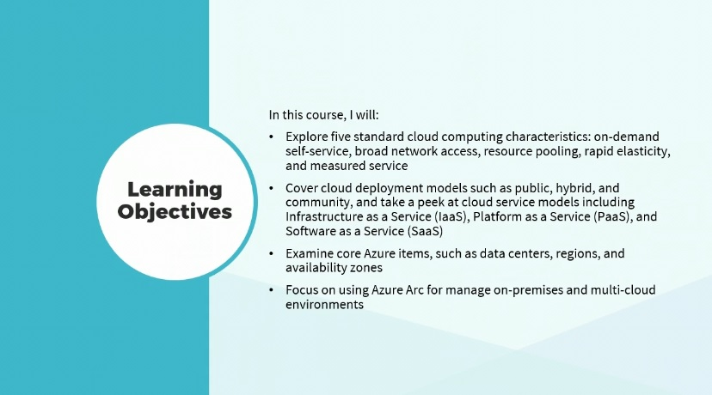

Hi there, I'm Dan Lachance.

The popularity of cloud computing has exploded in recent years.

Organizations can streamline IT service efficiency with the use of cloud services in the Microsoft Azure environment.

In this course, I’ll explore five standard cloud computing characteristics:

on-demand,

self-service,

broad network access,

resource pooling,

rapid elasticity, and measured service.

I will cover cloud deployment models such as public, hybrid, and community, and take a peek at cloud service models including Infrastructure as a Service or IaaS, Platform as a Service(PaaS), and Software as a Service (SaaS).

I will examine core Azure items, such as data centers, regions, and availability zones.

Finally, I will focus on using Azure Arc for managing on-premises and multi-cloud environments. This course can be used to prepare for exam AZ-900, Microsoft Azure Fundamentals.

**CLOUD COMPUTING CHARACTERISTICS**

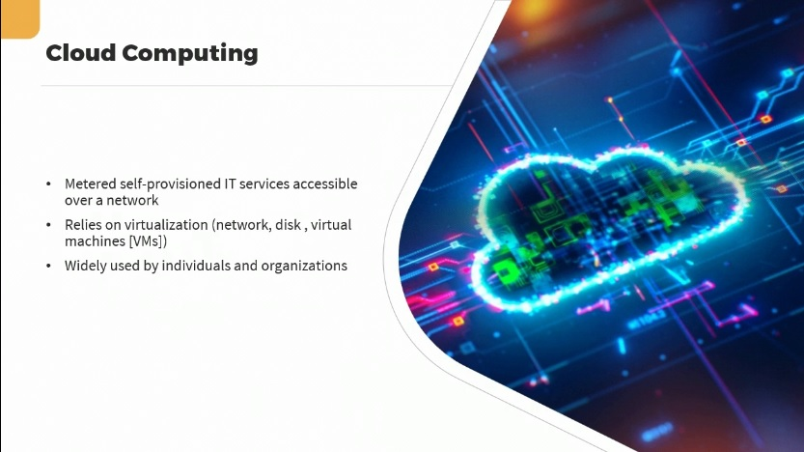

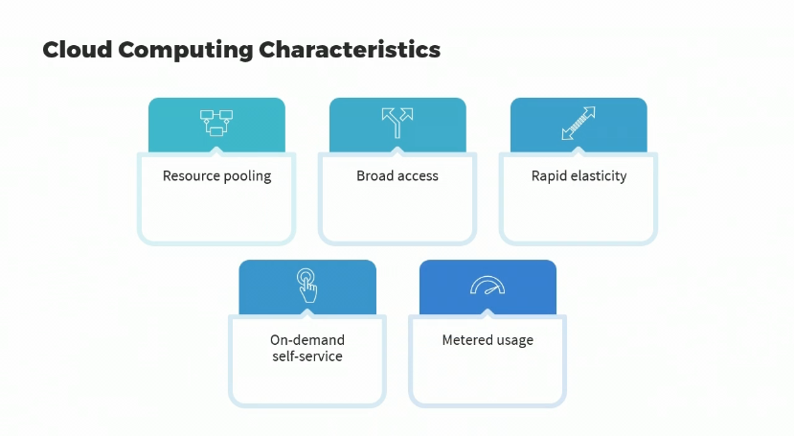

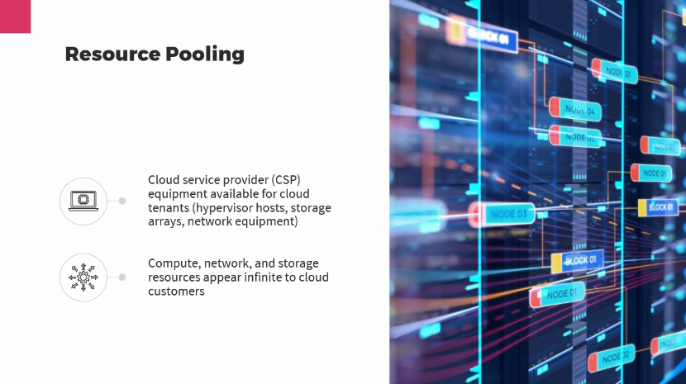

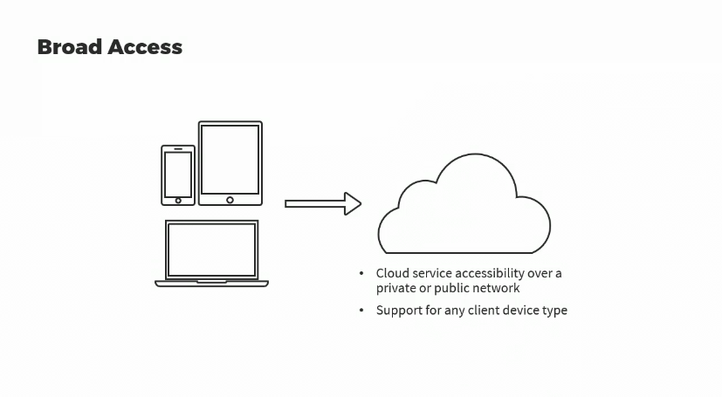

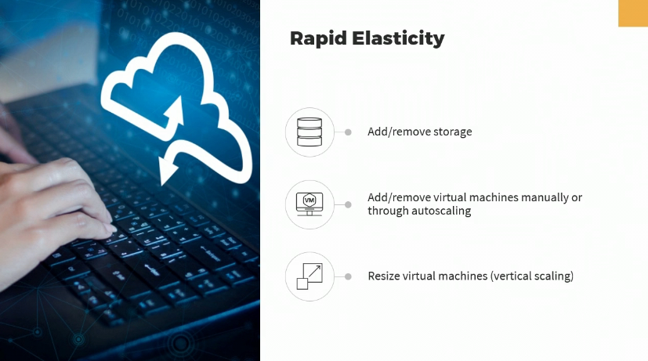

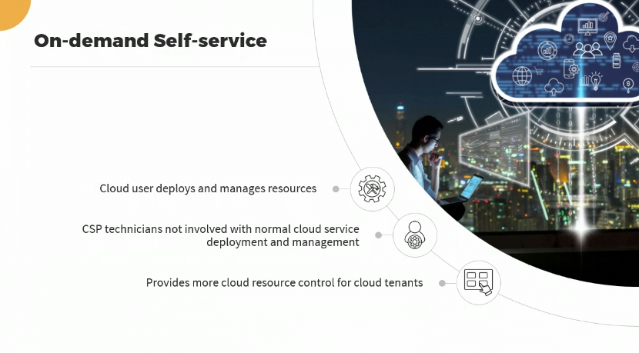

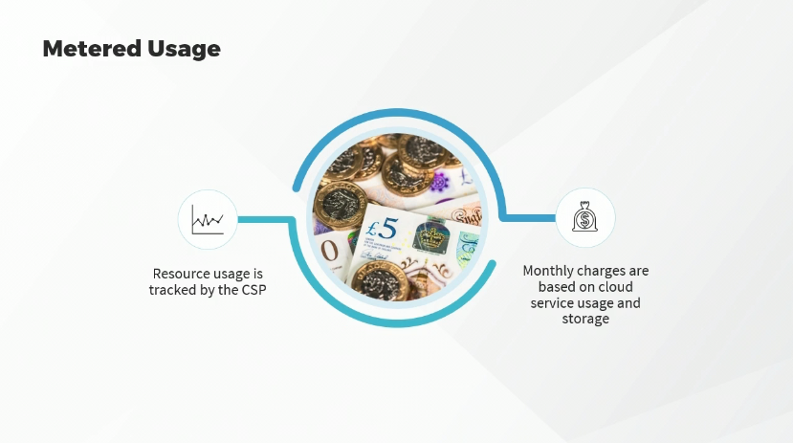

Understanding what makes cloud computing, **cloud computing, is one of the core concepts required for answering questions** on the AZ-900 exam.

Let’s focus on cloud computing.

Cloud computing essentially is a metered self-provisioned way to use IT services that are accessible over a network.

In other words, you’re connecting to IT services running somewhere else, on somebody else's equipment.

Cloud computing relies on virtualization in a number of different forms, such as, network virtualization, to allow us to configure virtual networks in the cloud, which can actually make changes to modify underlying network infrastructure equipment; disk virtualization, such as virtual disks used by virtual machines; and of course, running virtual machines or VMs on physical hypervisor hosts.

In this day and age, of course, cloud computing is widely popular for both individuals as well as organizations. But what makes using IT services cloud computing?

Let's define those characteristics.

The first characteristic is resource pooling.

Then we have broad access, rapid elasticity, on-demand self-service, and metered usage.

We're going to discuss each of these in a bit more detail.

Let's start with resource pooling.

What exactly does that mean when it comes to cloud computing? It means that the cloud service provider, otherwise known as the CSP, has buildings or rent space in a data center somewhere, where their equipment is available to be used by cloud customers or cloud tenants. So, having physical servers configured as hypervisor hosts, which can run multiple virtual machines; physical storage arrays that can be used for cloud storage; physical network equipment that can be used to allow networking of IT services available in the cloud. So, the resources are compute based, running virtual machines on hypervisors, network and storage, and these would appear to be almost infinite to cloud customers as the CSP can add underlying equipment as required to the cloud customer.

It just looks like they have more resources available.

They can deploy more space, let's say in a Microsoft Azure storage account, or deploy more virtual machines to be running concurrently.

And the economies of scale, where there are many cloud customers, make this affordable by CSPs in terms of purchasing the underlying physical hardware to allow the running of all of these types of IT services.

So, resource pooling is one cloud computing characteristic.

All characteristics have to be met in order to say that we have a cloud environment.

The next one is broad access. This means that the cloud services are available over a network, so you don't have to be running it on your own equipment.

Now, that can be over a private network, because you can have a private cloud and we’ll talk about that later or it might be available over a public network, such as customers accessing Microsoft Azure resources over the Internet.

Broad access also implies that we can connect from pretty much any type of device, whether it’s a smartphone, a server making API calls into the cloud, a desktop, a laptop, it doesn’t matter. So, broad access is our second cloud computing characteristic.

The third is rapid elasticity.

This means that we can do things very quickly with minimal configuration, because we're not dealing with the actual underlying hardware.

We're doing it through software virtualization, such as, the ability to easily and quickly add and remove storage, or the ability to easily and quickly add and remove virtual machines; whether we’re doing that manually or whether we’ve configured autoscaling, such as for a load balancer, when things get busy, it automatically adds virtual machines; when things quiet down, it removes them to save on costs.

Rapid elasticity also means that we can quickly resize a virtual machine.

This is called vertical scaling.

It means we can add more horsepower, more processors or faster processors, more RAM; we can do that in a matter of seconds, as opposed to in the real world, where you would have to order the appropriate equipment and configure it before you had that increase in underlying horsepower. So, that’s rapid elasticity.

The fourth cloud computing characteristic is called on-demand self-service.

This means that cloud customers, cloud users, are the ones that deploy and manage those cloud resources, such as virtual machines or storage accounts. Cloud customers don't send a helpdesk ticket to Microsoft asking for the creation of a virtual machine or a storage account.

The cloud customer does all of that.

So, therefore, cloud service provider technicians are not involved with standard cloud service deployment or management.

Of course, they might be involved when it comes to technical support, if cloud customers are experiencing problems. So, what this means is, it provides cloud resource control for cloud tenants.

They determine what gets deployed when, and in what way.

Our last cloud computing characteristic is metered usage.

This means that whatever we use in the cloud, resource usage, is tracked by the cloud service provider; much like electricity, the amount of electricity you use is tracked and you pay your bill accordingly. So, monthly charges for cloud computing then are based on cloud service usage and the amount of storage that you’re using.

One important aspect of the AZ-900 exam is having the ability to control costs in the Azure cloud, while maintaining service and availability. We’ll, be focusing on cost management later.

**VIRTUALIZATION AND THE MICROSOFT AZURE CLOUD**

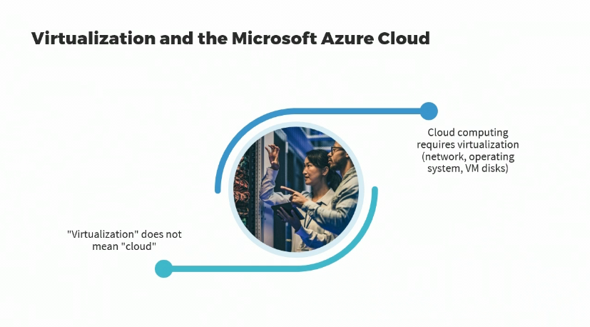

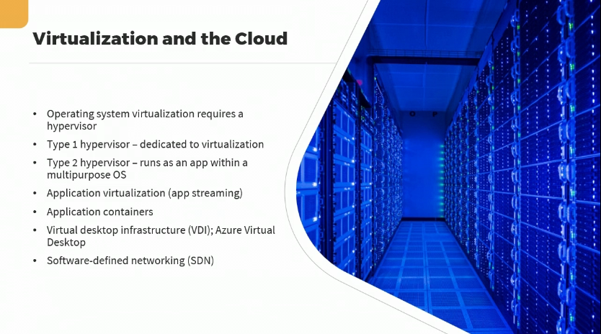

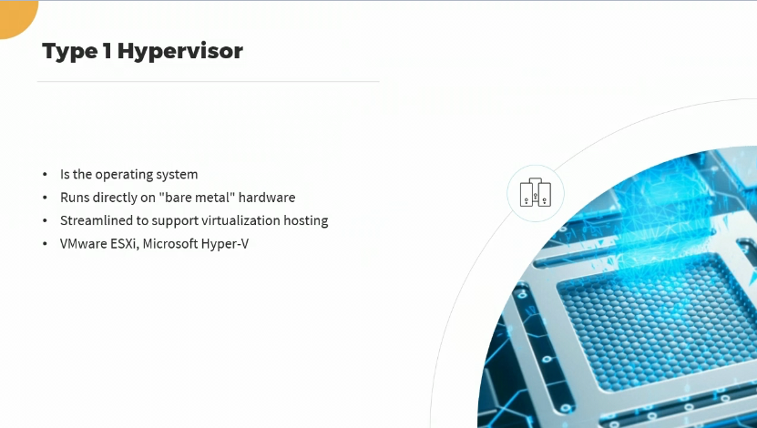

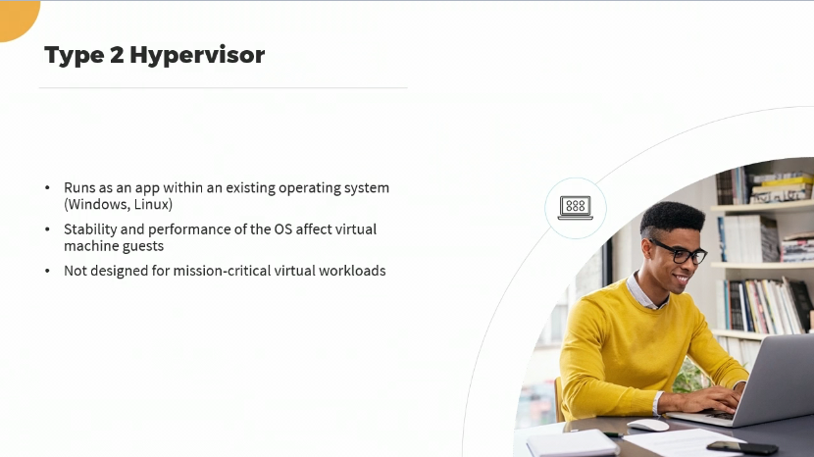

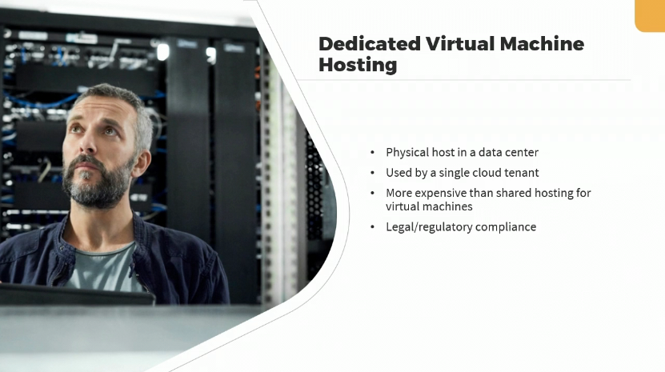

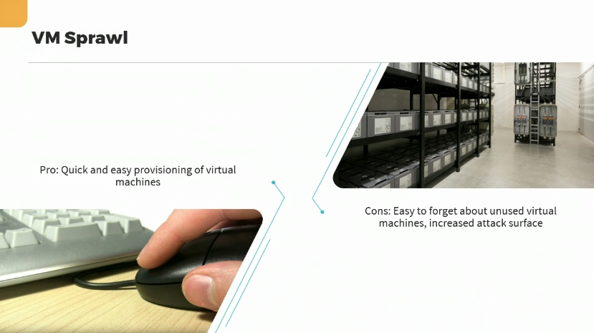

**CLOUD DEPLOYMENT MODELS**

